DELHI TECHNOLOGICAL UNIVERSITY



STOCHASTIC PROCESSES

(MC-303)

PRACTICAL FILE

SUBMITTED TO:

PROF. H C TANEJA

MR. VINEET KUMAR

SUBMITTED BY:

NITYA MITTAL

(2K19/MC/089)

EXPERIMENT 7

# AIM

Demonstrating Simple Random Walk (Cont.) WAP to find the probability that in case of:

(i) An unrestricted simple random walk the particle is at the kth position at time n using the CLT

(ii) A random walk with two absorbing barriers, the probability of absorption at a specific barrier

(iii) A random walk with two reflecting barriers, steady state probability distribution for the possible states.

Evaluate all these for designing specific example.

# THEORY

In mathematics, a random walk is a mathematical object, known as a stochastic or random process, that describes a path that consists of a succession of random steps on some mathematical space such as the integers.

An elementary example of a random walk is the random walk on the integer number line, which starts at 0 and at each step moves +1 or −1 with equal probability. Other examples include the path traced by a molecule as it travels in a liquid or a gas (see Brownian motion), the search path of a foraging animal, the price of a fluctuating stock and the financial status of a gambler: all can be approximated by random walk models, even though they may not be truly random in reality.

## SOURCE CODE

i)

function [p] = randwalk(p, q, j, k)

if p + q < 1

c = 0.5;

else

c = 1;

end

mean = p-q;

sd = sqrt(p+q-(p-q)^2);

p = normcdf((k+c-n*mean)/(sd*sqrt(n)))-normcdf((j-c-n*mean)/(sd*sqrt(n)));

end

ii)

function [answer] = markovchain(p,q,r,n,c) tpm1 = zeros(n,n);

for i=1:n

for j=1:n

if i-j == -1 && i~=1 && i~=n

tpm1(i,j) = p;

elseif i-j == 0 && i~=1 && i~=n

tpm1(i,j) = r;

elseif i-j == 1 && i~=1 && i~=n

tpm1(i,j) = q;

end end

end switch c

case 1

tpm1(1,1) = 1;

tpm1(n,n) = 1;

case 2

tpm1(1,1) = 1-p;

tpm1(1,2) = p;

tpm1(n,n) = 1;

end

answer = tpm1;

for i=1:n

answer = answer*tpm1;

end

end

## OUTPUT

i)

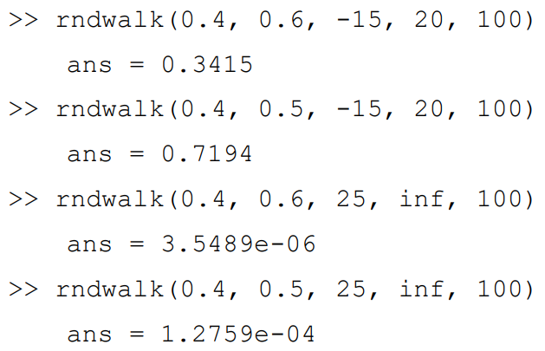

ii)

